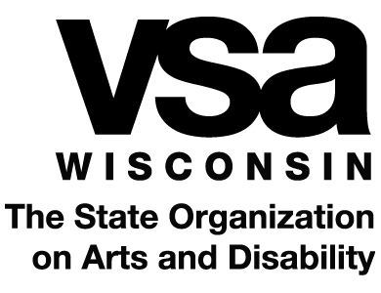

ARTSPARKS APPLICATION

Today’s Date:

# Program Hours Requested: 1.5 Fee: $12.50/student or minimum of $100 if group is fewer than 8
# Program Hours Requested: 3 Fee: $25/student or minimum of $200 if group is fewer than 8

Art Form Requested: visual art music movement drama creative writing

Submitted by (Agency/School): __ ______________
Address: Phone: ______________
City: Zip Code: ______________

Contact Person: ___ ______________
Name and Title Signature
Email: Phone: ______________

Administrator: ______________
Name and Title Signature

Submit completed applications to:

VSA Wisconsin
1709 Aberg Ave., Suite 1
Madison, WI 53704
Phone: 608-241-7583; Fax: 608-241-1982
Email: vsawis@vsawis.org

1. Indicate the time of year, day of week and times of day that will work best for a VSA program.

2. Identify the goals you wish to achieve through the program. What do you hope will change for participants and staff as a result of a VSA ArtSpark? Please be specific.

Program Demographics
Please include only participants who will have direct contact with the artist during the program when answering the following questions.

Estimate the age and number of individuals that will participate in this program.

Number of participants with disabilities:  Include participants who have a disability, an IEP or are in the referral process, and/or who receive speech & language services | ______ | List the disabilities: | Ages:
Number of participants who qualify for/receive additional  supports or services:  Do not include participants already listed above. Include participants who have chronic health issues, and/or with physical, social, emotional, cognitive or behavioral delays/challenges | ______ | List the circumstances: | Ages:
Number of participants without disabilities: | ______
Total number of participants: | ______

